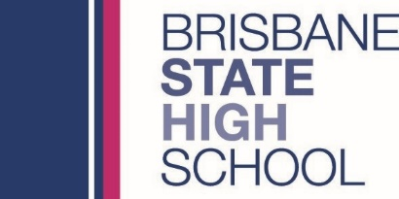
Uniform Shop Opening Hours

2021 Term 4 to 2022 Pre-Term 1

2021 – Term 4
Week 5
 | Date | Opening hours
Monday  Tuesday | 1 - 2 November | 8:00am to 12:30pm
Wednesday | 3 November | Closed
Thursday  Friday | 4 - 5 November | 8:00am to 12:30pm
Week 6
Monday  Tuesday | 8 - 9 November | 8:00am to 12:30pm
Wednesday | 10 November | Closed
Thursday  Friday | 11 - 12 November | 8:00am to 12:30pm
Week 7
Monday  Tuesday | 15 - 16 November | 11:30am to 12:30pm
Wednesday  Thursday  Friday | 17 - 19 November | 8:00am to 12:30pm
Week 8
Monday to Friday | 22 - 26 November | Closed - New Student Fittings only
Week 9
Monday to Friday | 29 November - 3 December | Closed - New Student Fittings only
Week 10
Monday to Friday | 6 - 10 December | Closed - New Student Fittings only

2022
2022 – Pre-Term 1
Monday  Tuesday | 17 - 18 January | 11:30am to 6:30pm
Wednesday  Thursday | 19 - 20 January | 10:00am to 5:00pm
Friday | 21 January | Closed

2022 – Term 1, Weeks 1 to 10
Date | Opening hours
Monday  Tuesday | 8:00am to 12:30pm
Wednesday | Closed
Thursday  Friday | 8:00am to 12:30pm

